WEEK 8
Date: |  | Day: MONDAY |  |  | Strand: All Around Us
 |  |  |  |  | Sub Strand: CHANGING WEATHER CONDITIONS
Class: KG 2 |  |  | Class Size:
Content Standard:  K2.6.9.1 Demonstrate understanding of positive and negative effects of weather conditions. |  |  |  | Indicator:  K2.6.9.1.7 Collect and handle data on learner’s preference of weather conditions.
PERFORMANCE INDICATOR:  - Collect and handle data on learner’s preference of weather conditions. |  |  |  |  | Core Competencies:  Communication and collaboration, Critical thinking, Personal Development and Leadership
Keywords: album,, label, leaves
Reference : KG Curriculum P.g. 173-176
Phase/Duration | Learners Activities |  |  |  |  | Resources
PHASE 1: STARTER | Engage learners to sing songs and play games.  WE CAN COUNT  We K1  We can count,  We count 1, 2, 3, 4 ,5  We count 6, 7, 8, 9, 10  We k1, we can count very well
PHASE 2: NEW LEARNING  CIRCLE TIME | Revise with learners on the theme of the week. Have learners to sing songs relating to the theme.
GROUP ACTIVITY 1  (OUTDOOR) | Follow the procedure for using the Language Experience Approach (LEA) to create an informational text on types of light and their sources  Teach rhymes and songs as learners sing along  Have learners dance with actions as they sing the songs  Make a choice to use any of the learning centers created.
PHONICS | Engage learners to sing songs and recite some familiar rhymes that relates to the target sound.  Guide learners to pronounce and write the target sound in the sand tray or exercise books.  Have learners say three or four words that contain the target sound.  Using flash cards, learners read words that contain the target sound.  1. What sound have we learnt today?  2. Which other letter sound do you know?  3. Mention any object in the classroom or home that begins with the target letter sound. |  |  |  |  | Word cards, letter cards.
GROUP ACTIVITY 2  (INDOOR) | conditions each person like most.  Learners count and represent data in a graphical form and in groups.  Use the data to ask questions such as  e.g. Which group has the most members? Count them.  Which group has few members?  Is there a group with no one? Etc.  Also scaffold learners to develop conceptual understanding of subtraction (0 to 20).  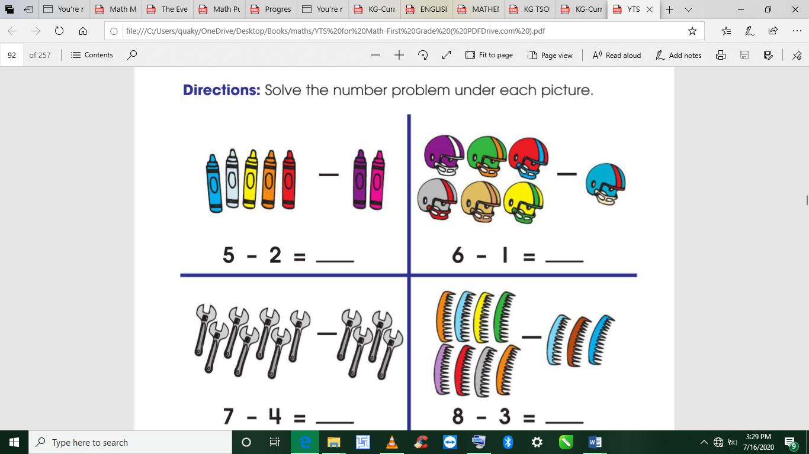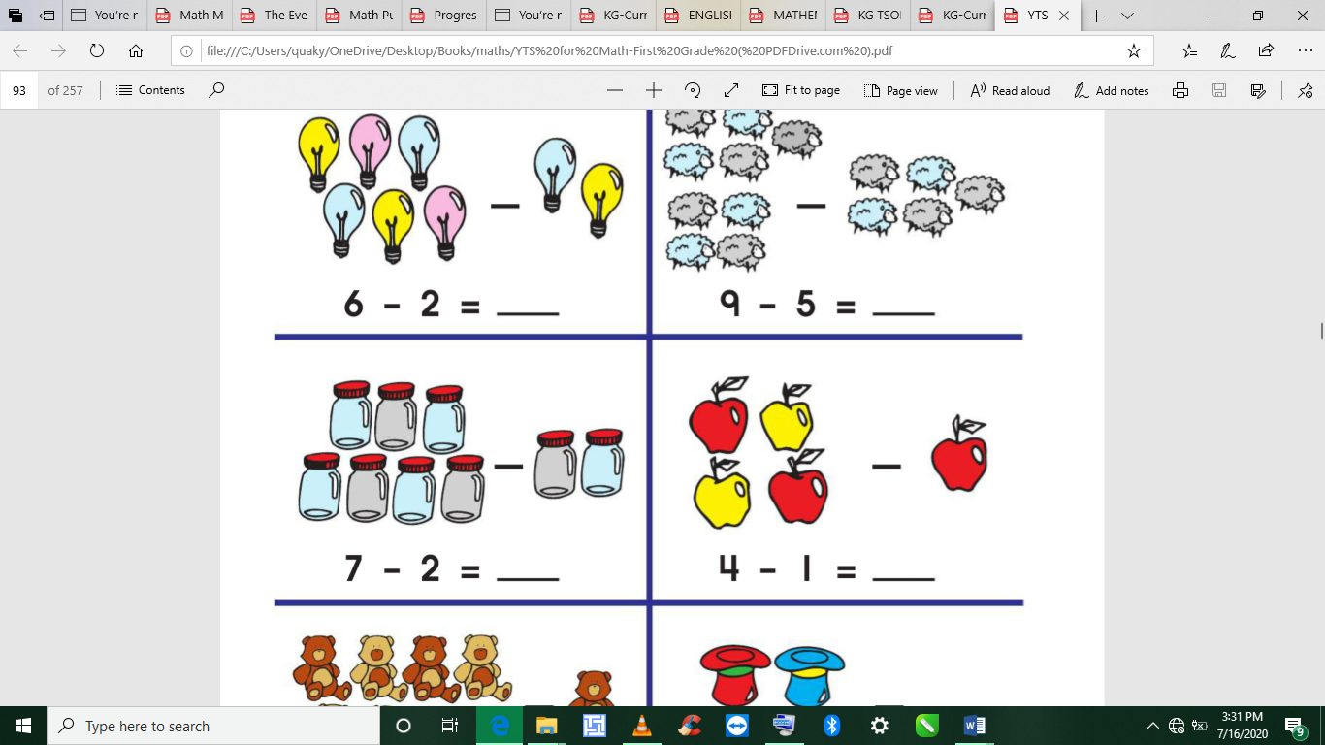  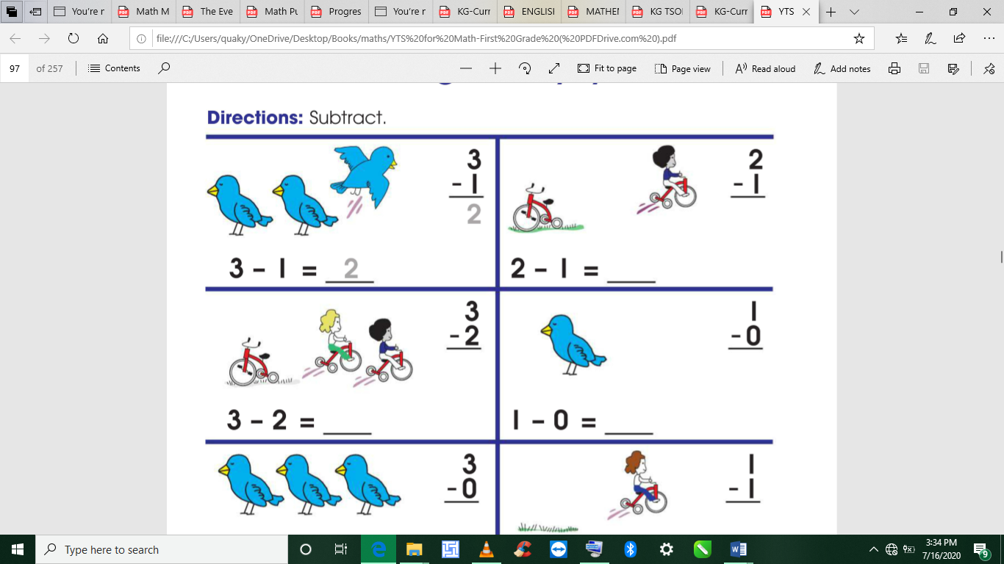  Ask if the whole class has 20 members and 10 pupils do not prefer any weather condition, how many will be left to dress up?  Guide learners to subtract numbers using countable objects. |  |  |  |  | Pictures and videos of past and present leaders in the community, Big book
LEARNING CENTER | Engage learners to play freely at the learning centers.  Observe, join in and ask learners questions frequently to guide their play and to support their understanding in what they are learning. |  |  |  |  | Learning center
STORY SHARING | Tell learners a story.  Pause regularly and ask questions to make sure learners are following.  Engage learners to act parts of the story.  1. Was the story interesting?  2. What part of the story did you like?  3. what have you learnt from the story? |  |  |  |  | Word cards, letter cards.
PHASE 3: REFLECTION | Learners share what they have learnt with their peers and class.  Teacher sings songs and recite rhymes in relation to the lesson with learners  Give learners homework to do at home.

Date: |  | Day: TUESDAY |  |  | Strand: All Around Us
 |  |  |  |  | Sub Strand: CHANGING WEATHER CONDITIONS
Class: KG 2 |  |  | Class Size:
Content Standard:  K2.6.9.1 Demonstrate understanding of positive and negative effects of weather conditions. |  |  |  | Indicator:  K2.6.9.1.6 Role play how changing weather conditions affect the clothes we wear
Performance Indicator:  - Learners Role play how changing weather conditions affect the clothes we wear |  |  |  |  | Core Competencies:  Communication and collaboration, Critical thinking, Personal Development and Leadership
Keywords: Plants, roots, leaves, stem.
Reference : KG Curriculum P.g. 173-176
Phase/Duration | Learners Activities |  |  |  |  | Resources
PHASE 1: STARTER | RAINY DAY  Rain, rain, rain  Falling, falling down  Drip drop drip drop  Rain hits the ground  Wet, wet, wet,  There is no outside play.  Puddles and puddles.  I want a sunny day!
PHASE 2: NEW LEARNING  CIRCLE TIME | Give learners a set of words with same beginning letter sounds and ask them to identify the letter sound, e.g. Bag, ball, bat, let learners circle the beginning letter sound,
GROUP ACTIVITY 1  (OUTDOOR) | Take leaners out of the class to the field for a stretch up.  Engage leaners to use any of the play toys available.  Make a choice to use any of the learning centers created  Listen to a story
PHONICS | Engage learners to sing songs and recite some familiar rhymes that relates to the target sound.  Guide learners to pronounce and write the target sound in the sand tray or exercise books.  Have learners say three or four words that contain the target sound.  Using flash cards, learners read words that contain the target sound.  1. What sound have we learnt today?  2. Which other letter sound do you know?  3. Mention any object in the classroom or home that begins with the target letter sound. |  |  |  |  | Word cards, letter cards.
GROUP ACTIVITY 2  (INDOOR) | Play the game: Look who is here today and what is the weather condition?  Group learners according to the weather conditions and have them role play dressing up in different weather conditions.  Have them wear clothes in relation to the weather conditions.  Group A dress like it is rainy (boots, rain coat, umbrella),  Group B wears very warm clothing and pullovers to show it is cold,  Group C, wears sleeveless simple dresses,  Group D wears things to cope with a windy day.  Learners enter the classroom and walk by and others guess what the weather condition is.  Recite different rhymes related to the weather to end the day. |  |  |  |  | Pictures and videos of past and present leaders in the community, Big book
LEARNING CENTER | Engage learners to play freely at the learning centers.  Observe, join in and ask learners questions frequently to guide their play and to support their understanding in what they are learning. |  |  |  |  | Learning center
STORY SHARING | Tell learners a story.  Pause regularly and ask questions to make sure learners are following.  Engage learners to act parts of the story.  1. Was the story interesting?  2. What part of the story did you like?  3. what have you learnt from the story? |  |  |  |  | Word cards, letter cards.
PHASE 3: REFLECTION | Learners share what they have learnt with their peers and class.  Give learners homework to do at home.

Date: |  | Day: WEDNESDAY |  |  | Strand: All Around Us
 |  |  |  |  | Sub Strand: CHANGING WEATHER CONDITIONS
Class: KG 2 |  |  | Class Size:
Content Standard:  K2.6.9.1 Demonstrate understanding of positive and negative effects of weather conditions. |  |  |  | Indicator:  K2.6.9.1.1 Identify and describe the elements the different weather conditions.
Performance Indicator:  - Identify and describe the elements the different weather conditions.  - Use a variety of new vocabulary learnt about the theme to create an informational text for reading using LEA |  |  |  |  | Core Competencies:  Communication and collaboration, Critical thinking, Personal Development and Leadership
Keywords: fruits, leaves, roots, stem, plants.
Reference : KG Curriculum P.g. 173-176
Phase/Duration | Learners’ Activities |  |  |  |  | Resources
PHASE 1: STARTER |   SUNNY DAY  Yellow sun yellow sun  Shinning down so bright  Sunshine, sunshine  Giving lots of light  The sun is warm,  Its hits my face.  It really makes me smile  I don’t want the sun to leave  So please stay for awhile
PHASE 2: NEW LEARNING  CIRCLE TIME | Learners learn and say the rhyme  “whether the weather…”  whether the weather be cold,  or whether the weather be hot,  we’ll whether the weather,  whatever the weather ,  whether we like it or not.
GROUP ACTIVITY 1  (OUTDOOR) | Follow the procedure for using the Language Experience Approach (LEA) to create an informational text on the changing conditions of the weather and what learners do.  Take Learners out of the class to the field for a stretch up.  Engage Learners to use any of the play toys available.  Make a choice to use any of the learning centers created
PHONICS | Engage learners to sing songs and recite some familiar rhymes that relates to the target sound.  Guide learners to pronounce and write the target sound in the sand tray or exercise books.  Have learners say three or four words that contain the target sound.  Using flash cards, learners read words that contain the target sound.  1. What sound have we learnt today?  2. Which other letter sound do you know?  3. Mention any object in the classroom or home that begins with the target letter sound. |  |  |  |  | Word cards, letter cards.
GROUP ACTIVITY 2  (INDOOR) | Follow basic procedures of the community circle time and introduce the theme for the week.  Display a Conversational Poster #8 and some concrete materials related to the theme, and engage learners in active discussion on the following leading questions: what makes the weather dull or bright? what do we like to do when the weather is bright and sunny or rainy and dull? |  |  |  |  | Pictures and videos of past and present leaders in the community, Big book
LEARNING CENTER | Engage learners to play freely at the learning centers.  Observe, join in and ask learners questions frequently to guide their play and to support their understanding in what they are learning. |  |  |  |  | Learning center
STORY SHARING | Tell learners a story.  Pause regularly and ask questions to make sure learners are following.  Engage learners to act parts of the story.  1. Was the story interesting?  2. What part of the story did you like?  3. what have you learnt from the story? |  |  |  |  | Word cards, letter cards.
PHASE 3: REFLECTION | Learners share what they have learnt with their peers and class.  Give learners homework to do at home.

Date: |  | Day: THURSDAY |  |  | Strand: All Around Us
 |  |  |  |  | Sub Strand: CHANGING WEATHER CONDITIONS
Class: KG 2 |  |  | Class Size:
Content Standard:  K2.6.9.1 Demonstrate understanding of positive and negative effects of weather conditions. |  |  |  | Indicator:  K2.6.9.1.2 participate actively in the shared reading of the big book which relates to the theme and answer simple questions on the text.  K2.6.9.1.3 Use a variety of new vocabulary learnt about the theme to create an informational text for reading using LEA  K2.6.9.1.4 read level appropriate content sight words and use them to form sentences and also copy them in their books.
Performance Indicator:  - Learners can participate actively in the shared reading of the big book which relates to the theme and answer simple questions on the text.  - Learners can read level appropriate content sight words and use them to form sentences and also copy them in their books. |  |  |  |  | Core Competencies:  Communication and collaboration, Critical thinking, Personal Development and Leadership
Keywords: Plants, roots, leaves, stem.
Reference : KG Curriculum P.g. 173-176
Phase/Duration | Learners Activities |  |  |  |  | Resources
PHASE 1: STARTER | CLOUDY DAY  I see clouds,  They look so puffy.  Big and little,  Light and fluffy  Clouds block the sun  They bring the shade  Look really closely  See what pictures are made  I really don’t mind a cloudy day,  But look out!  Rain could be on the way.
PHASE 2: NEW LEARNING  CIRCLE TIME | Take learners through before reading activities to activate pupils’ previous knowledge on the theme.  Read aloud the informational text about different types of soil while pointing to words in a sentence.  Ask factual and inferential questions about the book. E.g. Why was it difficult for the girl to catch the moon?.
GROUP ACTIVITY 1  (OUTDOOR) | As usual, put learners in a community circle. Let them sing the song on plants, clap their hands and dance as well.  Show key words of the theme on cards and guide learners to read them.  Engage Learners to use any of the play toys available.  Make a choice to use any of the learning centers created  Listen to a story
PHONICS | Engage learners to sing songs and recite some familiar rhymes that relates to the target sound.  Guide learners to pronounce and write the target sound in the sand tray or exercise books.  Have learners say three or four words that contain the target sound.  Using flash cards, learners read words that contain the target sound.  1. What sound have we learnt today?  2. Which other letter sound do you know?  3. Mention any object in the classroom or home that begins with the target letter sound. |  |  |  |  | Word cards, letter cards.
GROUP ACTIVITY 2  (INDOOR) | Provide learners with word chart on weather conditions – dry, cold, wet, windy, rainy, cloudy, warm, sunny, sun, water.  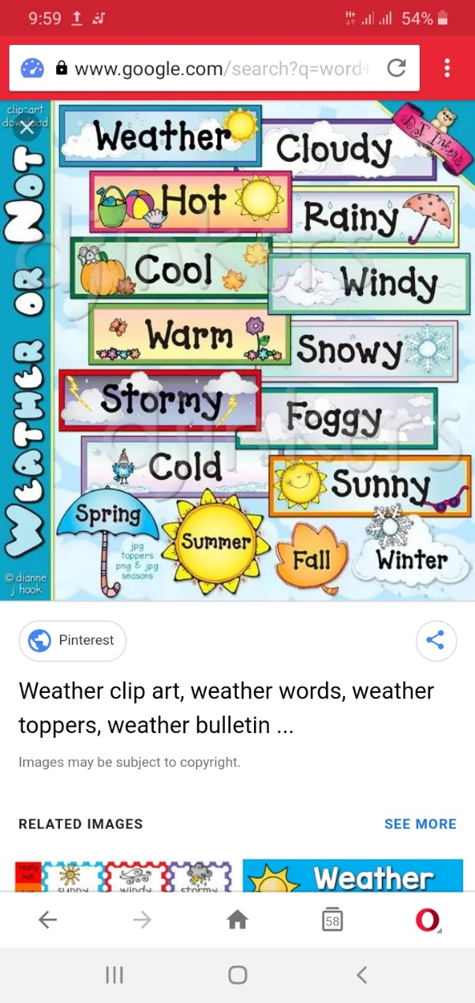  Scaffold learners to read the words and decode the simple sentences using their decoding strategies learnt so far.  Follow the steps of the KWL strategy instruction as you read aloud the informational text on the weather to the learners.  Pause often and let learners find answers to their questions.  Learners first say what they know about the weather(K), ask questions on what they want to know, listen to the text and answer their own questions during the reading and share what they have learnt about the weather.  Learners talk about their experiences, e.g. with floods, the scorching sun, windy weather conditions |  |  |  |  | Pictures and videos of past and present leaders in the community, Big book
LEARNING CENTER | Engage learners to play freely at the learning centers.  Observe, join in and ask learners questions frequently to guide their play and to support their understanding in what they are learning. |  |  |  |  | Learning center
STORY SHARING | Tell learners a story.  Pause regularly and ask questions to make sure learners are following.  Engage learners to act parts of the story.  1. Was the story interesting?  2. What part of the story did you like?  3. what have you learnt from the story? |  |  |  |  | Word cards, letter cards.
PHASE 3: REFLECTION | Learners share what they have learnt with their peers and class.  Give learners homework to do at home.

